Ripped Foil - Children

Zeynep Civelek

July, 08 2020

## Exploring the data

The structure of the data is shown below with all the variable names and levels of measurement.

## 'data.frame': 1088 obs. of 15 variables:  
## $ id : Factor w/ 68 levels "14","15","16",..: 1 1 1 1 1 1 1 1 1 1 ...  
## $ age : Factor w/ 3 levels "3","4","5": 3 3 3 3 3 3 3 3 3 3 ...  
## $ agemonths: num 62.9 62.9 62.9 62.9 62.9 ...  
## $ ageyears : num 5.24 5.24 5.24 5.24 5.24 ...  
## $ agecat : Factor w/ 3 levels "five","four",..: 1 1 1 1 1 1 1 1 1 1 ...  
## $ sex : Factor w/ 2 levels "1","2": 1 1 1 1 1 1 1 1 1 1 ...  
## $ order : Factor w/ 2 levels "penfirst","stickerfirst": 1 1 1 1 1 1 1 1 1 1 ...  
## $ boxtype : Factor w/ 2 levels "blue-right","pink-right": 1 1 1 1 1 1 1 1 1 1 ...  
## $ trialtype: Factor w/ 2 levels "pen","sticker": 1 1 1 1 1 1 1 1 2 2 ...  
## $ order2 : int 1 1 1 1 1 1 1 1 2 2 ...  
## $ order3 : Factor w/ 2 levels "test","transfer": 1 1 1 1 1 1 1 1 2 2 ...  
## $ trialno : int 1 2 3 4 5 6 7 8 1 2 ...  
## $ side : Factor w/ 2 levels "L","R": 1 2 2 1 2 1 1 2 2 1 ...  
## $ response : Factor w/ 3 levels "","L","R": 3 2 2 3 2 3 3 2 3 2 ...  
## $ correct : int 1 1 1 1 1 1 1 1 1 1 ...

We decided to use age as a continuous variable (age in months) in our main analyses rather than categorical to have more power.The distribution of age:

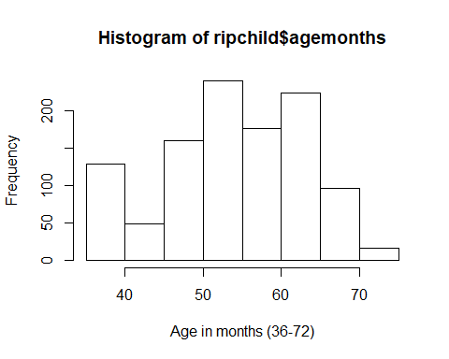

Next I aggregated the trial-by-trial data to create one score per child for Test and Transfer phases as well as an overall score so I can check the distributions of scores.

## Histograms for Test and Transfer Phases and an overall score (ripchild_individual)

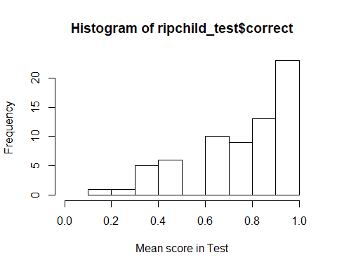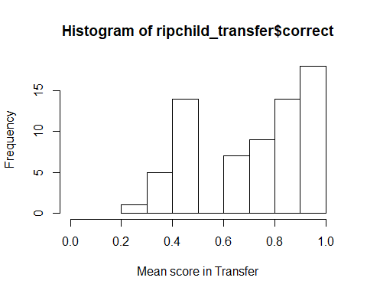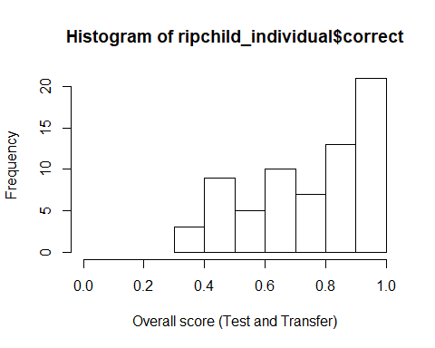

## Preparation of the data for running the GLMM

* Z-transformations for 'trial no' and 'age in months'
* Coding dummy variables for trialtype, sex and phase (order3)
* Centering the random slope components for these variables.

## Full model

contr<-glmerControl(optimizer="bobyqa", optCtrl=list(maxfun=10000000))  
full<-glmer(correct ~ trialtype*order3+z.trialno+z.age*order3+sex+(1|id)+(0+z.trialno+order3.transfer.c+trialtype.sticker.c|id),data=ripchild, family=binomial, control=contr)

## boundary (singular) fit: see ?isSingular

The full model does not include box type (the location of the blue/pink box) as a random effect anymore due to convergence issues. But there is a singular fit warning here as you can see.

## Model assumptions

#### Distribution of random effects

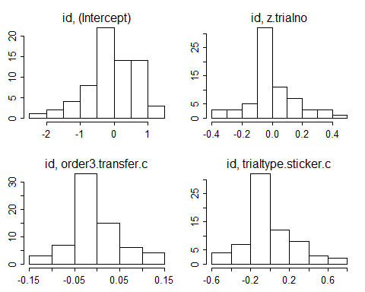

#### Model stability

## [1] "please carefully evaluate whether the result makes sense, and if not, please contact me"

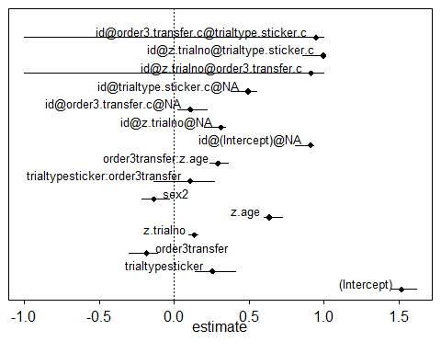

#### Multicollinearity

## trialtype order3 z.trialno z.age sex   
## 1.000 1.000 1.000 1.021 1.021

None of these seem to show a problem.

## Null model

null<-glmer(correct~ z.trialno+(1|id)+(0+z.trialno+order3.transfer.c+trialtype.sticker.c|id),data=ripchild, family=binomial, control=contr)

## boundary (singular) fit: see ?isSingular

## Full and Null comparison

## Data: ripchild  
## Models:  
## null: correct ~ z.trialno + (1 | id) + (0 + z.trialno + order3.transfer.c +   
## null: trialtype.sticker.c | id)  
## full: correct ~ trialtype * order3 + z.trialno + z.age * order3 + sex +   
## full: (1 | id) + (0 + z.trialno + order3.transfer.c + trialtype.sticker.c |   
## full: id)  
## npar AIC BIC logLik deviance Chisq Df Pr(>Chisq)   
## null 9 1122.3 1167.3 -552.17 1104.3   
## full 15 1100.2 1175.1 -535.09 1070.2 34.164 6 < 2.2e-16 ***  
## ---  
## Signif. codes: 0 '***' 0.001 '**' 0.01 '*' 0.05 '.' 0.1 ' ' 1

The full model is significantly different than the null model.

## Model output

#### Coefficients

## Estimate Std. Error z value Pr(>|z|)  
## (Intercept) 1.517 0.282 5.370 0.000  
## trialtypesticker 0.256 0.335 0.764 0.445  
## order3transfer -0.184 0.329 -0.560 0.576  
## z.trialno 0.135 0.090 1.491 0.136  
## z.age 0.635 0.168 3.772 0.000  
## sex2 -0.135 0.288 -0.468 0.640  
## trialtypesticker:order3transfer 0.108 0.569 0.190 0.849  
## order3transfer:z.age 0.293 0.174 1.685 0.092

#### Individual predictor: Likelihood tests

## Single term deletions  
##   
## Model:  
## correct ~ trialtype * order3 + z.trialno + z.age * order3 + sex +   
## (1 | id) + (0 + z.trialno + order3.transfer.c + trialtype.sticker.c |   
## id)  
## npar AIC LRT Pr(Chi)   
## <none> 1100.2   
## z.trialno 1 1100.4 2.228 0.136   
## sex 1 1098.4 0.218 0.641   
## trialtype:order3 1 1098.2 0.036 0.849   
## order3:z.age 1 1101.1 2.926 0.087 .  
## ---  
## Signif. codes: 0 '***' 0.001 '**' 0.01 '*' 0.05 '.' 0.1 ' ' 1

**The interactions terms are not significant (although there is a trend for test/transfer scores to vary by age) so I will remove them from the model.**

## Reduced model without the interactions

## Full model 2

full2=glmer(correct ~ trialtype+order3+z.trialno+z.age+sex+(1|id)+(0+z.trialno+order3.transfer.c+trialtype.sticker.c|id),data=ripchild, family=binomial, control=contr)

## boundary (singular) fit: see ?isSingular

## Null model

null2<-glmer(correct~ z.trialno+(1|id)+(0+z.trialno+order3.transfer.c+trialtype.sticker.c|id),data=ripchild, family=binomial, control=contr)

## boundary (singular) fit: see ?isSingular

#### Full 2 and null comparision

## Data: ripchild  
## Models:  
## null2: correct ~ z.trialno + (1 | id) + (0 + z.trialno + order3.transfer.c +   
## null2: trialtype.sticker.c | id)  
## full2: correct ~ trialtype + order3 + z.trialno + z.age + sex + (1 |   
## full2: id) + (0 + z.trialno + order3.transfer.c + trialtype.sticker.c |   
## full2: id)  
## npar AIC BIC logLik deviance Chisq Df Pr(>Chisq)   
## null2 9 1122.3 1167.3 -552.17 1104.3   
## full2 13 1099.1 1164.0 -536.57 1073.1 31.211 4 < 2.2e-16 ***  
## ---  
## Signif. codes: 0 '***' 0.001 '**' 0.01 '*' 0.05 '.' 0.1 ' ' 1

**Full model is significantly different than the null model.**

## Model output

#### Coefficients

## Estimate Std. Error z value Pr(>|z|)  
## (Intercept) 1.540 0.241 6.396 0.000  
## trialtypesticker 0.297 0.176 1.690 0.091  
## order3transfer -0.218 0.172 -1.269 0.205  
## z.trialno 0.137 0.090 1.520 0.129  
## z.age 0.782 0.148 5.299 0.000  
## sex2 -0.129 0.288 -0.450 0.653

#### Individual predictors : Likelihod ratio tests

## Single term deletions  
##   
## Model:  
## correct ~ trialtype + order3 + z.trialno + z.age + sex + (1 |   
## id) + (0 + z.trialno + order3.transfer.c + trialtype.sticker.c |   
## id)  
## npar AIC LRT Pr(Chi)   
## <none> 1099.1   
## trialtype 1 1100.0 2.856 0.091 .   
## order3 1 1098.7 1.605 0.205   
## z.trialno 1 1099.5 2.315 0.128   
## z.age 1 1123.2 26.077 <2e-16 ***  
## sex 1 1097.3 0.202 0.653   
## ---  
## Signif. codes: 0 '***' 0.001 '**' 0.01 '*' 0.05 '.' 0.1 ' ' 1

**Age emerges as a significant predictor of scores. There also seems to be a pattern of scores varying by trial type.**

#### Calculating effect sizes for the final model

## R2m R2c  
## theoretical 0.13190079 0.3358856  
## delta 0.09146174 0.2329075

Here we look at the row headed delta. Marginal R-squared is the variance explained by the fixed effects and the conditional R-squared is the variance explained by the fixed and random effects (the model).

## Scatterplot 1 to see the effect of age in the overall score.

*Running a separate model for the CI calculation.

#running a new model for CI predictions  
full.CI=glmer(correct ~ z.trialno+order3.transfer.c+trialtype.sticker.c+z.age+sex.m.c+(1+z.trialno+order3.transfer.c+trialtype.sticker.c|id),data=ripchild, family=binomial, control=contr)

## boundary (singular) fit: see ?isSingular

**Question: Did you intentionally include the correlations between slopes and intercepts in this model Christoph?**

#### Overall performance across age:

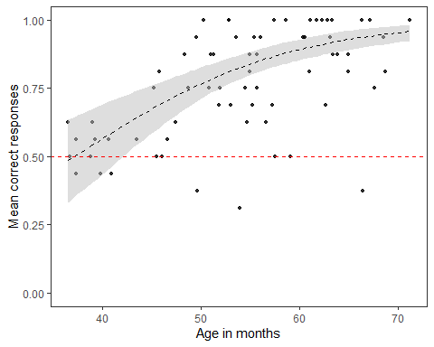

**Performance of younger children (up until 50 months of age) seem to be at or below chance level in this task. Older children seem to be doing better although there is a lot of variation (some are performing at ceiling level while some others are below chance).**

#### Running a new model for calculating CIs for the interaction model so we can plot the performance in test and transfer across ages separately.

full.CI.int<-glmer(correct ~ trialtype.sticker.c+z.age*order3+sex.m.c+z.trialno+(1|id)+(0+z.trialno+order3.transfer.c+trialtype.sticker.c|id),data=ripchild, family=binomial, control=contr)

#### 

#### Performance in Test and Transfer across age:

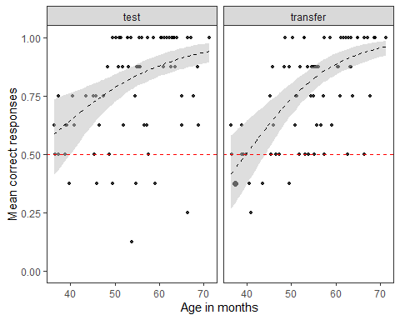

**Younger children's (up until 50 months of age) scores in both test and transfer do not seem to differ from chance level compared to older children. The slope for the Transfer phase is also steeper than in Test level meaning that the difference between the younger and older children's performance in Transfer is larger.** This is great to see but we will leave this to the supplementary materials.

## First trial performance in Transfer phase

We expect younger children to make more errors when they switch from test to transfer if they are solving the task using an arbitrary rule.

* Getting the data for the first trial of Transfer

#### Performance in trial 1 of Transfer phase

firsttrial <- glm(correct~agemonths+sex+trialtype,data=ripchild_1st_trial,family=binomial(link = "logit"))  
summary(firsttrial)

## Call:  
## glm(formula = correct ~ agemonths + sex + trialtype, family = binomial(link = "logit"),   
## data = ripchild_1st_trial)  
##   
## Deviance Residuals:   
## Min 1Q Median 3Q Max   
## -2.0658 -1.0328 0.5699 0.8060 1.5530   
##   
## Coefficients:  
## Estimate Std. Error z value Pr(>|z|)   
## (Intercept) -4.36231 1.80644 -2.415 0.01574 *   
## agemonths 0.09633 0.03414 2.822 0.00478 **  
## sex2 -0.02901 0.57703 -0.050 0.95990   
## trialtypesticker 0.22316 0.57090 0.391 0.69588   
## ---  
## Signif. codes: 0 '***' 0.001 '**' 0.01 '*' 0.05 '.' 0.1 ' ' 1  
##   
## (Dispersion parameter for binomial family taken to be 1)  
##   
## Null deviance: 84.069 on 67 degrees of freedom  
## Residual deviance: 74.436 on 64 degrees of freedom  
## AIC: 82.436  
##   
## Number of Fisher Scoring iterations: 4

**Age emerges as a significant predictor of first trial performance of Transfer.** We can plot this as:

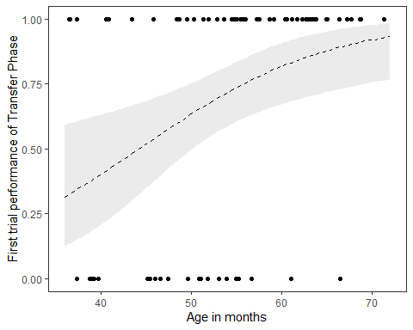

**Younger children tend to make more errors than older children**